Importing ASCII File

* Download **pycharm** <https://www.jetbrains.com/pycharm/nextversion/>
* Download Driver for computer <https://docs.microsoft.com/en-us/sql/connect/odbc/download-odbc-driver-for-sql-server>
* Download **pyodbc** after you have installed pycharm
  + Open up Pycharm
  + Go to **File**
  + Go to **Settings…**
  + Then go to **Project: PycharmProject**
    - Then click **Project Interpreter**
  + Then click on the **+** symbol on right
  + Then type in at the top **pyodbc** and then choose **pyodbc**
  + Then click the **Install Package**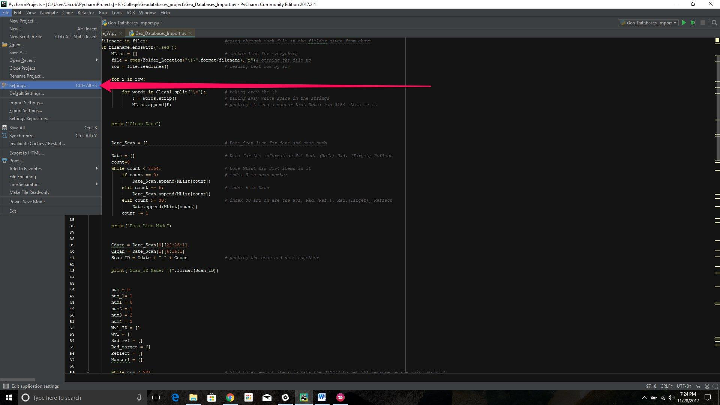

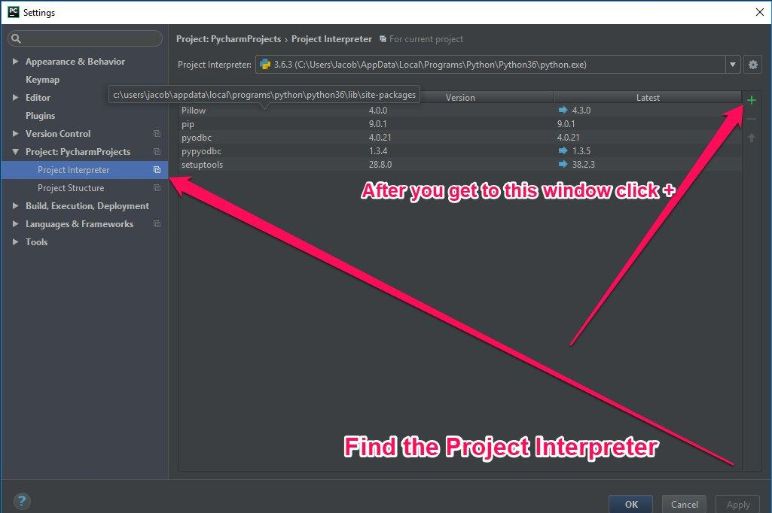

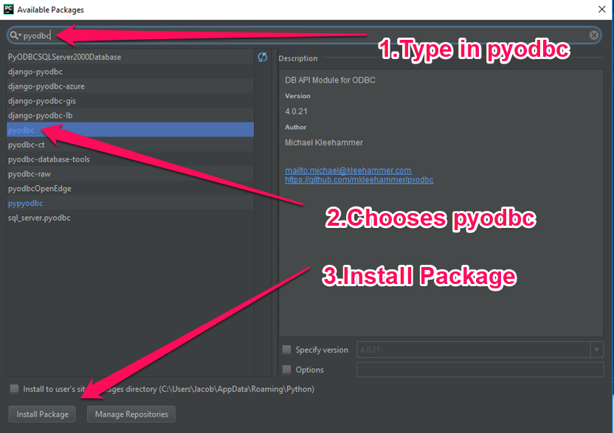

**To use the Code**

1. Find the folder with all of the ASCII files in it
   1. You should not have any ASCII files in the folder in which have already be place into the databases in the past because it will insert duplicates
2. Copy and Past the folder directory into the code at **Line 3**
   1. 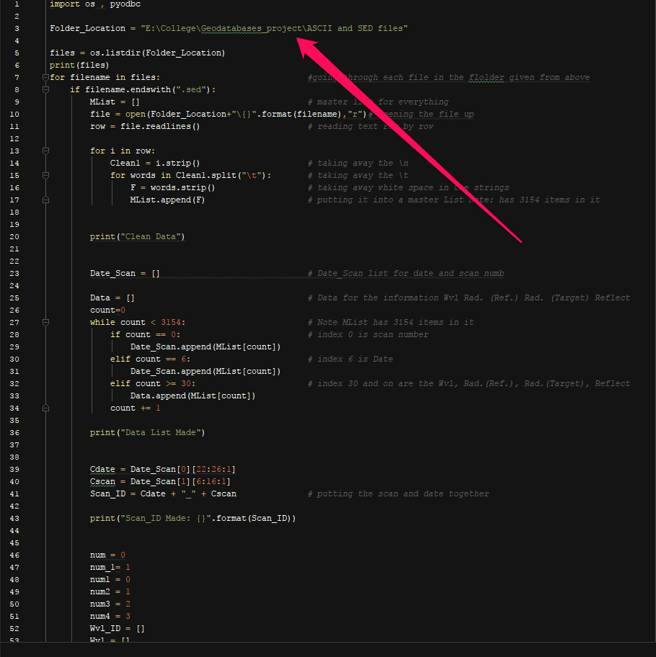
   2. Make sure to place quotation around the directory
3. Make a folder into which you want the outputted text files to be placed
4. Copy and Past the folder directory where the text files will be made into the code at **Line 82**
   1. 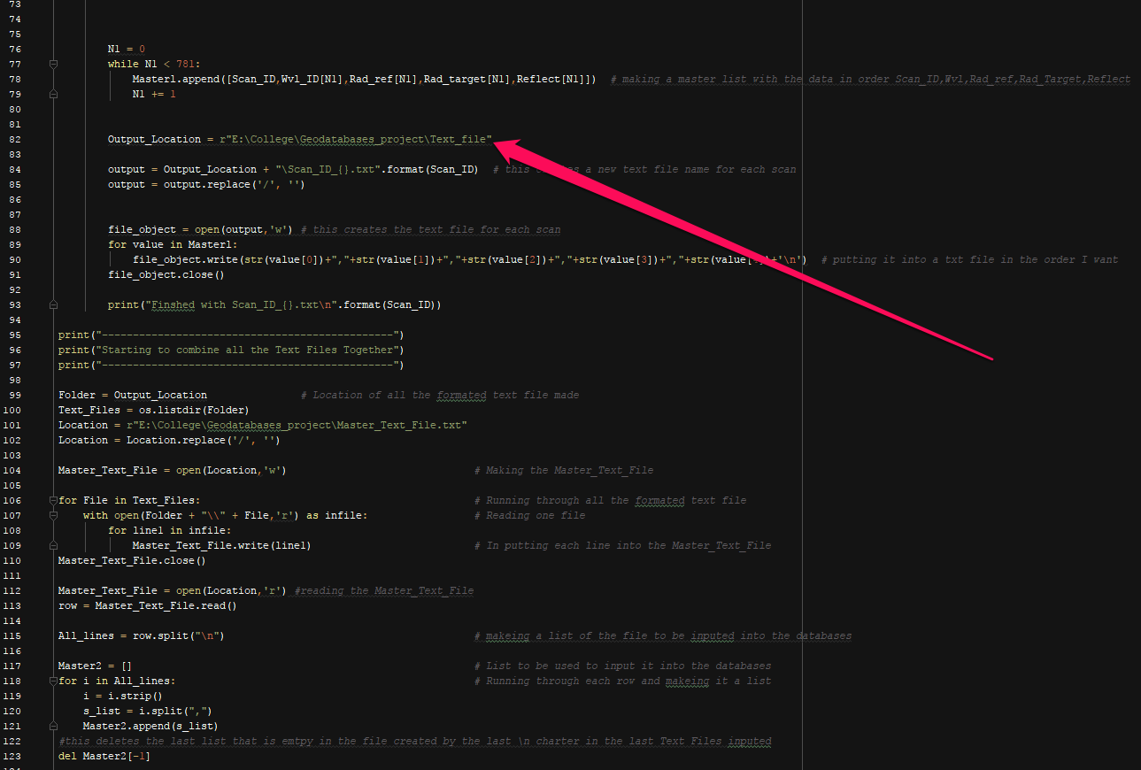
   2. Make sure to place quotation around the directory
5. Last thing is to check on the connection to the SQL server
   1. DRIVER = {SQL Server} (This should stay the same no matter what)
   2. server = the name of you SQL server (check screenshot for more/example)
   3. database = will be the database name that you created (check screenshot for more/example)
   4. uid = is you user name to get into the SQL server normally (check screenshot for more/example)
   5. pwd = is your password to get into the SQL server normally (check screenshot for more/example)

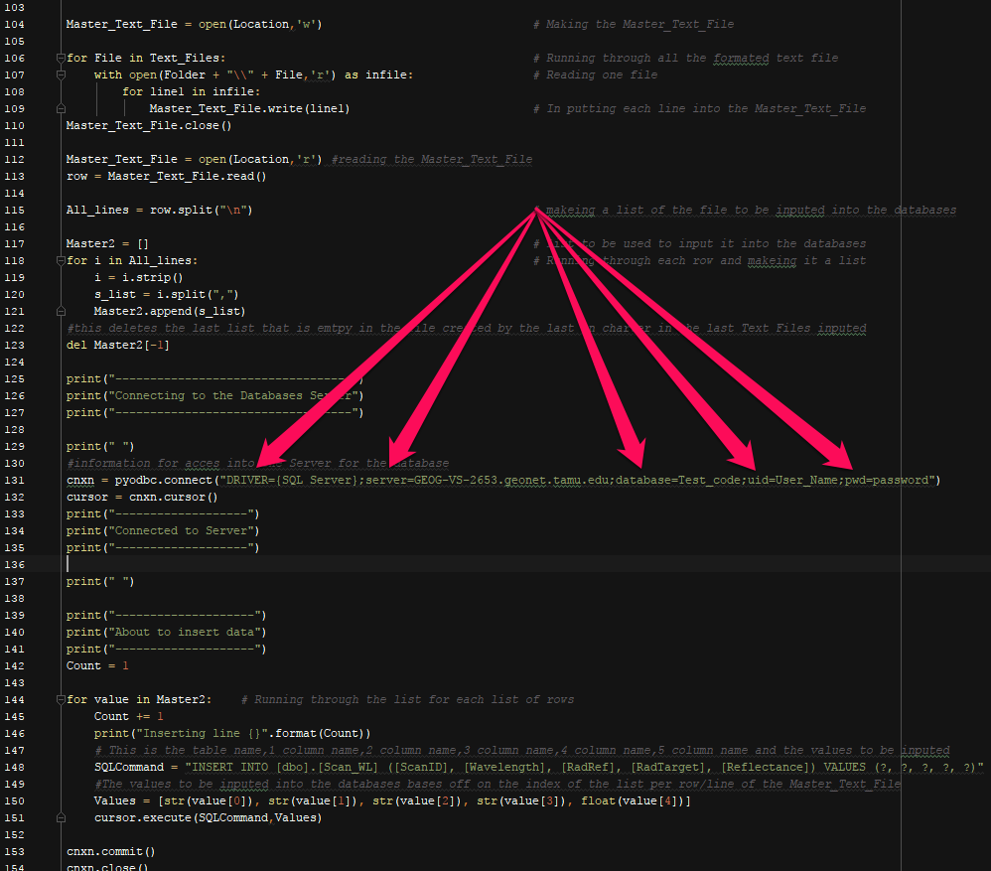

1. Now you can **Run** the code at the top of pycharm
2. Then click **Run…**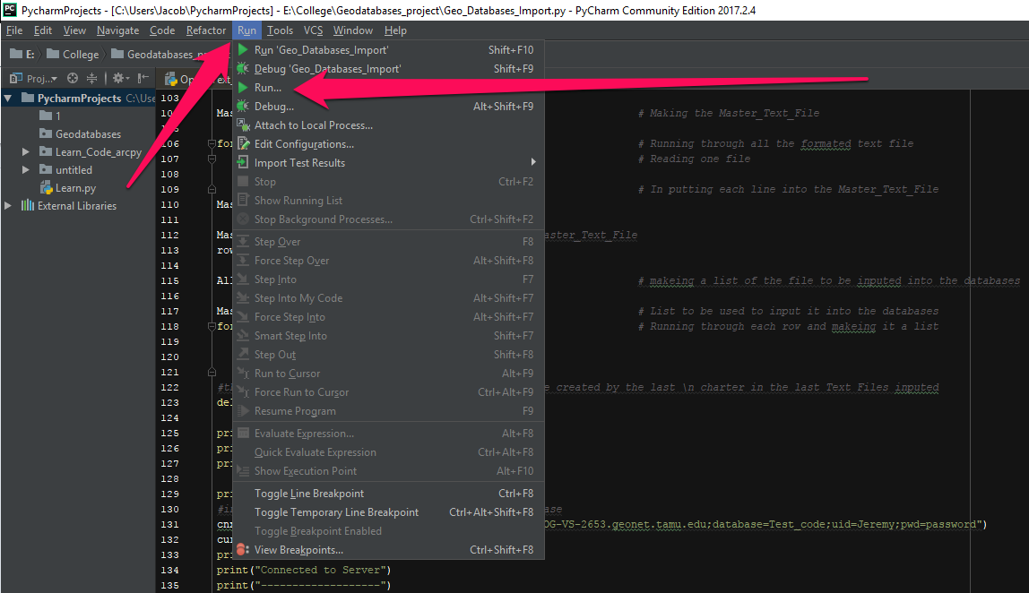
3. Then in the window that opens up choose the code **Geo_Databases_Import**

